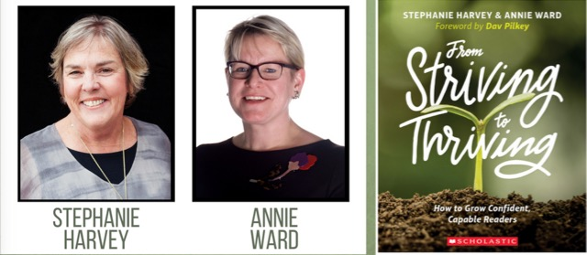
The Literacy Connection Presents:
From Striving to Thriving:
How to Grow Confident, Capable Readers
Grade: K-8
Stephanie Harvey and Annie Ward

Please complete the registration form and email to ktaps@icloud.com or mail to Kathleen Taps, 3838 Lakedale Dr., Hilliard, OH, 43026. If using a credit card, please click on the PayPal link on our website. Make checks payable to The Literacy Connection. Purchase orders are accepted. There will be no refunds.

Name: _________________________________________________________________

Address: ________________________________________________________________

City: ___________________________________ State: _________ Zip Code: ________

School District: __________________________________________________________

School: ________________________________________ Position: _________________

E-Mail Address: __________________________________________________________

Home Phone # ____________________________ Work Phone #___________________

Please mark the session(s) you will be attending.

___ General Session: Annie Ward
Saturday, Oct. 19, 2019 8:30 AM-2:30 PM
Tyler Run Elementary (Olentangy Local Schools)
580 Salisbury Drive
Powell, OH 43065
Cost $75.00

___ General Session: Stephanie Harvey
Saturday, April 18, 2020 8:30 AM-2:30 PM
Tyler Run Elementary (Olentangy Local Schools)
580 Salisbury Drive
Powell, OH 43065
Cost $75.00

Please note: The Literacy Connection regrets that we will not be able to include a copy of the book From Striving to Thriving as part of registration payment as we have done in the past. Copies of the book will be available for purchase at the sessions.

Payment Information:
____ Registration paid with credit card using PayPal www.theliteracyconnection.org.

____ Registration paid with district purchase order #_________________.

____ I have mailed a check payable to The Literacy Connection.

____ I have received a scholarship to cover the cost of registration.

____ Other: ________________________________________

Acknowledgement:
____ I acknowledge that there will be no refunds.
Donation:
____ I would like to make a donation to The Literacy Connection and have included the following amount in my check: ____________

Certificates of Attendance for 5 contact hours per session will be available at the
conclusion of each session at the registration table.
Opportunity for credit through individual school districts:
The Literacy Connection is not offering Ashland University study group credit. We are supporting the current trend of credits earned for professional development within districts.
We will provide general information for districts that are interested in offering college credit for staff members who attend the two full day sessions with the literacy experts, as well as meet course expectations to complete the number of contact hours required by the college or university providing class credit for your staff development opportunities. Your district may choose to incorporate some of these ideas in their proposal or they might draft their own content.

Please visit our website, www.theliteracyconnection.org for up to date information. For questions concerning our program go to our website or contact Kathleen Taps at ktaps@icloud.com.

